

## AMERICAN INTERNATIONAL UNIVERSITY–BANGLADESH (AIUB)

**Department of Computer Science (CS) Faculty of Science &Technology (FST) Fall 2023-2024**

## Software Development Project Management Group Project

**Laundry Management System**

# Section: B

Submitted By:

|  |  |
| --- | --- |
| **NAME** | **ID** |
| **Syed Mohibur Rahman** | **20-42043-1** |

Supervised By:

# MD. ANWARUL KABIR

Date of Submission: 23/12/2023

# Introduction

A Laundry Management System (LMS) is a digital platform or software designed to streamline and automate the entire process of managing laundry operations, whether for individual users or laundry service providers. It serves as an intermediary between customers looking for laundry services and the businesses providing these services.

## Key Features:

**System Feature: Home Page:**

## Quality Attributes:

* + 1. **Usability:**

**Clear Navigation**: The homepage should have a clear and organized menu or navigation bar, guiding users to essential sections like services, pricing, and contact.

**Search Functionality:** A search bar, if applicable, should be prominent and functional.

**Onboarding:** First-time users should get clear guidance or a brief tutorial on how to use the system.

* + 1. **Aesthetics:**

**Visual Appeal:** The design should be clean, modern, and resonate with the branding of the service.

**Consistent Design:** Fonts, colors, and design elements should be consistent throughout.

**Optimized Images:** Images should be high-quality but optimized for quick loading.

* + 1. **Performance:**

**Loading Speed:** The homepage should load swiftly, within a few seconds, to retain user interest.

**Responsive Design:** The design should adapt to different devices (mobile, tablet, desktop) ensuring a seamless experience.

* + 1. **Accessibility:**

**Color Contrast:** Text and background colors should have sufficient contrast for readability.

**Font Size & Readability:** Text should be easily readable, and users should have the option to adjust font size if needed.

**Keyboard Navigation:** Users should be able to navigate the homepage using just the keyboard.

**Alt Text for Images:** All images should have appropriate alt text for screen readers.

* + 1. **Reliability:**

**Uptime:** Essential links and features on the homepage should always be functional.

**Error Handling:** If there's an error (like a failed promotional banner load), it shouldn't break the entire homepage layout.

* + 1. **Security:**

**Secure Connections:** If there are login or signup options on the homepage, they should use secure protocols (e.g., HTTPS).

**Data Input Validation:** Any form or input field on the homepage should validate data to prevent injections or malicious use.

* + 1. **Interactivity:**

**Feedback:** Interactive elements (like buttons) should provide feedback on hover, click, or touch.

**Chat or Support:** Consider adding a chatbot or live chat feature for immediate user assistance.

* + 1. **Content Quality:**

**Clear Messaging:** The purpose of the LMS and its primary offerings should be clearly communicated.

**Updated Information:** The homepage should display any important announcements or updates.

* + 1. **Scalability:**

**Dynamic Content Loading:** If the homepage displays dynamic content (like latest reviews or news), it should be able to handle varying amounts of data without affecting performance.

* + 1. **Testability:**

**Analytics Integration:** Tools like Google Analytics should be integrated to monitor user interactions and behavior on the homepage.

### Functional Requirements:

1. The home page should provide users with an overview of the laundry service.
2. The home page should allow users to navigate to different sections of the website.
3. The home page should include a search function that allows users to find laundry service providers by location.
4. The home page should display the most popular laundry service providers or promotions.
5. The home page should allow users to register or sign in to their account.
6. The home page should display information about the laundry service, such as pricing, delivery options, and payment methods.

**System Feature: Login**

### Functional Requirements:

1. Allow users (admin, office-employee, deliver, customer) to log in to their account using their email address or user name and password or social media credentials.
2. Allow users to reset their password in case they forget it.
3. Allow users to create an account by providing their basic details and contact information.

### Quality Attributes:

* 1. **Usability:** The login system must be user-friendly and easy to navigate for users of all technical backgrounds.
  2. **Security:** The login system must ensure the confidentiality and integrity of user credentials and prevent unauthorized access to user accounts.
  3. **Performance:** The login system must be fast and responsive to provide a seamless user experience.
  4. **Accessibility:** The login system must be accessible to users with disabilities or special needs.
  5. **Reliability:** The login functionality should be consistently available, barring scheduled maintenance. In case of server or service failures, there should be a message informing the user of the issue.
  6. **Aesthetics:** The login page should align with the branding of the LMS in terms of logos, colors, and fonts.

**Minimalistic Design:** A clutter-free design helps users focus on the primary action: logging in.

### Interactivity:

**Feedback:** Provide feedback when a user clicks the login button, such as a loading spinner, so they know the system is processing.

**Links to Other Pages:** Easy access to the homepage, registration page, or help page if required.

### Maintainability:

**Easy Updates:** It should be simple to update the login page's design or functionality without causing system-wide disruptions.

### Testability:

**Analytics Integration:** Integrate tools to monitor failed login attempts, user behavior, or other metrics that can help improve the user experience.

**Testing Features:** Support for end-to-end testing tools to ensure consistent functionality through updates.

### Scalability:

**Multiple Users:** The login system should handle a large number of simultaneous login requests without degradation in performance.

**System Feature: ADMIN**

*ADD The Features (office employee, delivery personnel, Laundry Company, add branch of different Laundry Company)

*Delete (Office employee, delivery personnel, Laundry Company)

*View (All information customer, office employee, delivery personnel, all company)

*Update (All information)

*Activities Track

**System Feature: Laundry Company**

*View Upcoming Orders

*Take Order from Deliver

*Update Order Status for Laundry Company

**System Feature: Office Employee**

* View Order from Customer and Laundry Service
* Shift Order to Deliver (Customer)

**\*** Shift Order to Deliver (Laundry Company)

* Track (Office Employee)

**System Feature: Delivery**

*View Assigned Deliveries

*Update Delivery Status

*Cancel Delivery

*View Customer Information

*Contact Customer

**System Feature: Customer**

*User Registration

*Laundry Service Provider Search

*Laundry Pickup and Delivery Scheduling

*Laundry Tracking Feature

*Rating and Review System

*Transparent Pricing and Payment Options

*Order Management System Feature

*Order Tracking

# 2.0 Project Title:

**Laundry Management System**

# 3.0 Objectives:

The main objectives and goals of a laundry management system can vary depending on the specific needs and requirements of the organization implementing it. However, here are some common objectives and goals associated with a laundry management system:

### Efficient Workflow:

Streamline the entire laundry process to ensure an efficient workflow from receiving dirty laundry to delivering clean and folded items.

### Inventory Management:

Keep track of laundry supplies, such as detergents, fabric softeners, and other cleaning agents, to ensure that there are always enough resources to handle the laundry workload.

### Resource Optimization:

Optimize the use of equipment, such as washing machines and dryers, to maximize efficiency and reduce energy consumption.

### Customer Satisfaction:

Ensure timely and accurate delivery of cleaned items to customers, enhancing overall customer satisfaction.

### Order Tracking:

Implement a system for tracking and managing laundry orders from initiation to completion, providing transparency to both staff and customers.

### Quality Control:

Implement quality control measures to ensure that laundry is cleaned according to specified standards and meets customer expectations.

### Cost Management:

Monitor and control operational costs associated with laundry services, including labor, utilities, and maintenance, to maintain profitability.

### Staff Productivity:

Improve staff productivity by providing tools and systems that streamline their tasks, reducing manual errors and increasing overall efficiency.

### Reporting and Analytics:

Generate reports and analytics to provide insights into laundry operations, helping management make informed decisions to optimize processes further.

### Compliance and Safety:

Ensure compliance with industry regulations and safety standards to create a secure and healthy working environment for employees and customers.

### Technology Integration:

Integrate the laundry management system with other relevant technologies, such as RFID tagging or barcode scanning, to enhance tracking and management capabilities.

### Scalability:

Design the system to be scalable, allowing it to handle increased volumes of laundry as the business grows.

### Environmental Sustainability:

Implement eco-friendly practices in laundry processes and use energy-efficient equipment to minimize the environmental impact.

### Customer Relationship Management (CRM):

Use the system to maintain customer profiles, preferences, and order history, facilitating personalized services and building strong customer relationships.

### Training and Development:

Provide training for staff to use the laundry management system effectively, ensuring that all employees are proficient in its use.

By focusing on these objectives and goals, a laundry management system can contribute to the overall efficiency, customer satisfaction, and sustainability of laundry operations.

# 4.0 Justification:

### Efficiency Enhancement:

The primary purpose of a laundry management system is to enhance the efficiency of laundry operations. By automating and streamlining tasks, such as order processing, inventory management, and quality control, the system reduces manual errors and accelerates the overall workflow.

### Customer Satisfaction:

Customers benefit from a laundry management system through improved service quality and timely deliveries. The system ensures that orders are processed promptly, and customers receive their cleaned items on schedule, leading to increased satisfaction and loyalty.

### Transparency and Accountability:

Staff members benefit from increased transparency and accountability in their tasks. The system provides a clear overview of each stage of the laundry process, allowing employees to track and manage orders efficiently. This transparency also contributes to a more accountable work environment.

### Data-Driven Decision Making:

Managers and business owners benefit from the data generated by the system. Analytics and reporting features enable informed decision-making, allowing for the identification of trends, areas for improvement, and strategic planning based on real-time and historical data.

# Benefited

Several stakeholders can benefit from the implementation of a laundry management system. Here's a breakdown of how different groups can experience advantages:

### Laundry Business Owners:

* + Operational Efficiency: Owners can streamline and optimize their laundry processes, reducing operational costs and enhancing overall efficiency.
  + Cost Control: The system helps in monitoring and controlling costs associated with resources, labor, and utilities, contributing to better financial management.
  + Data-Driven Decision Making: Access to real-time data and analytics enables informed decision-making for business growth and strategic planning.

### Managers and Supervisors:

* + Workflow Oversight: Managers can have a clear overview of the entire laundry workflow, allowing for better oversight and control.
  + Resource Optimization: The system assists in managing inventory levels, equipment usage, and staff allocation, optimizing resources for maximum efficiency.

### Laundry Staff:

* + Task Automation: Laundry staff benefit from the automation of routine tasks, reducing manual effort and minimizing the chances of errors.
  + Transparency: The system provides transparency in task assignments, order tracking, and overall workflow, making it easier for staff to collaborate and fulfill their responsibilities.

### Customers:

* + Timely Service: Customers experience timely and efficient laundry services, as the system helps in tracking orders and ensuring on-time deliveries.
  + Order Tracking: The system enables customers to track the status of their orders, providing transparency and reducing uncertainty.
  + Personalized Services: With integrated customer profiles, businesses can offer personalized services based on preferences and historical data.

### Suppliers:

* + Inventory Management: Suppliers benefit indirectly as the system helps in managing inventory efficiently, ensuring that the business orders supplies in a timely manner and avoids stockouts.

▪

### Regulatory Compliance Authorities:

* + Compliance: Regulatory authorities benefit from businesses using a laundry management system to ensure adherence to industry regulations and safety standards, promoting a safe and compliant environment.

### Environment:

* + Sustainability: The system contributes to environmental sustainability by promoting eco- friendly practices and the use of energy-efficient equipment, aligning with broader environmental goals.

### Technology Providers:

* + Market Demand: Providers of laundry management system technology benefit from increased market demand as more businesses seek to modernize and optimize their operations.

The laundry management system has a multi-faceted impact, benefiting various stakeholders by improving efficiency, reducing costs, enhancing customer satisfaction, and promoting sustainability. The advantages extend across the entire supply chain, creating a more streamlined and effective laundry operation.

# 5.0 Systems Overview:

### Figure 1: Use -Case Diagram.

In the above use case diagram, there are five actors named Admin, Office Employee, Delivery, Company and Customer. There are a total of 27 to 28 use cases that represent the specific functionality of a laundry management system. Each actor interacts with a particular use case.

# 6.0 Stakeholders analysis:

## Primary stakeholders:

**Admin:** Typically responsible for system administration, user management, and overseeing the entire system's functionality.

**Office Employee:** Likely involved in managing laundry orders, customer interactions, and possibly administrative tasks within the office.

**Delivery Personnel:** Involved in the delivery process, ensuring orders reach customers, and possibly handling pickups.

**Company:** This actor might represent the laundry service provider or the organization running the laundry management system.

**Customer:** The end-user who places orders, interacts with the system to track orders, and provides feedback.

## Secondary Stakeholders:

**Suppliers:** Those providing laundry supplies like detergents, machines, etc., might indirectly interact with the system by supplying necessary materials.

**Maintenance Personnel:** Individuals responsible for maintaining and repairing laundry equipment might also be stakeholders.

These stakeholders play different roles and have varied levels of interaction with the system. Their needs, concerns, and interactions would likely influence the design and functionality of the laundry management system.

# 7.0 Feasibility study:

A feasibility study for a laundry management system involves assessing the viability, practicality, and potential success of implementing such a system. Here's an outline of what such a study might include:

**Scope Definition:** Define the objectives and scope of the laundry management system.

**Identify key functionalities required:** order management, inventory tracking, customer management, etc.

**Market Analysis:** Evaluate the market demand for laundry services in the target area. Analyze competitors and their systems, noting strengths and weaknesses.

**Technical Feasibility:** Assess the technical requirements, such as hardware, software, and infrastructure. Determine if the technology needed is available and feasible within the budget.

**Operational Feasibility:** Evaluate how the system will integrate with existing operations. Consider training needs for staff to use the system effectively.

**Financial Feasibility:** Estimate the costs involved in system development, implementation, and maintenance. Compare the costs to potential savings or revenue generation facilitated by the system.

**Risk Assessment:** Identify potential risks and challenges associated with implementing the system. Develop mitigation strategies for identified risks.

**Legal and Regulatory Compliance:** Ensure the system complies with legal requirements, such as data protection laws. Identify any regulatory hurdles that might affect system implementation.

**Benefits Analysis:** Outline the expected benefits of the system, such as improved efficiency, reduced errors, and enhanced customer experience. Quantify these benefits wherever possible.

**Recommendations:** Based on the analysis, provide a recommendation on whether to proceed with the implementation of the laundry management system. Offer suggestions for alternative solutions or improvements.

# 8.0 Systems component:

In a laundry management system, several components work together to facilitate the efficient operation of the system. These components can be categorized into various subsystems or modules, each responsible for specific functionalities. Here are the key components commonly found in a laundry management system:

## User Interface:

* + Admin Dashboard: Provides access to system configurations, user management, and overall system control.
  + Employee Interface: Interface for office employees to manage orders, track inventory, handle customer requests, etc.
  + Customer Interface: Enables customers to place orders, track order status, make payments, and provide feedback.

## Order Management:

* + Order Processing: Module to handle order placement, modification, and cancellation.
  + Scheduling: Allows for scheduling pickups, deliveries, and managing service timelines.
  + Inventory Management: Tracks inventory levels of detergents, fabrics, and other supplies.

## Customer Relationship Management (CRM):

* + Customer Profiles: Stores customer information, order history, preferences, etc.
  + Feedback and Support: Mechanisms for customers to provide feedback and seek assistance.

## Billing and Payment:

* + Invoicing: Generates invoices for services rendered.
  + Payment Gateway Integration: Enables secure online payments.

## Reporting and Analytics:

* + Performance Reports: Provides insights into operational efficiency, order volumes, customer trends, etc.
  + Analytics Dashboard: Visualizes key metrics for better decision-making.

## Integration and Connectivity:

* + APIs and Integrations: Interfaces with third-party systems for services like payment gateways, CRM tools, etc.
  + Mobile App Integration: For customers to place orders and track status via mobile devices.

## Security and Authentication:

* + Access Control: Controls user access based on roles and permissions.
  + Data Encryption: Ensures the security of sensitive information.

## Logistics and Delivery Management:

* + Route Optimization: Optimizes delivery routes for efficiency.
  + Real-time Tracking: Enables real-time tracking of delivery status for customers and management.

## System Administration and Maintenance:

* + Backup and Recovery: Ensures data integrity through regular backups.
  + System Updates and Maintenance: Keeps the system up-to-date and running smoothly.

These components collectively form the backbone of a laundry management system, providing the necessary tools and functionalities to streamline operations, enhance customer experience, and manage the entire laundry service efficiently.

# 9.0 Process Model to be followed:

After analyzing the requirements, it was evident that, the following software has multiple users and the functionality of the software is fixed to serve the users properly. No additional functional requirements are needed to fulfill the objective. However, there should be testing stages to validate and verify process for each functionality, so that they may be correctly applied for each user.

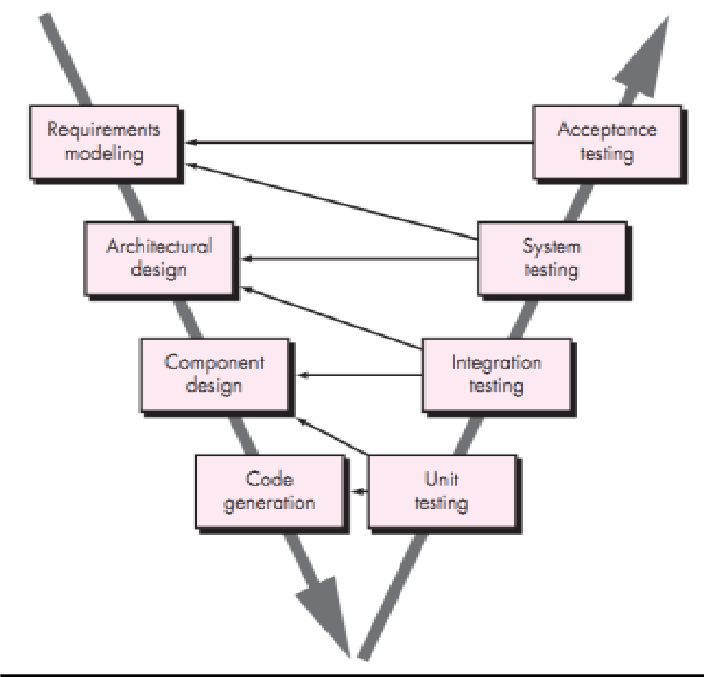So, the required process model must be linear sequential model, for example, Waterfall Model. But here the V-Model has been chosen as the software need to be tested in each section thoroughly. Moreover, V-Model is an extension of the waterfall model and is based on association of a testing phase for each corresponding development stage. This means that for every single phase in the development cycle there is a directly associated testing phase. This is a highly disciplined model and next phase starts only after completion of the previous phase

# Efforts estimation:

* + - **Work Break own Structure**

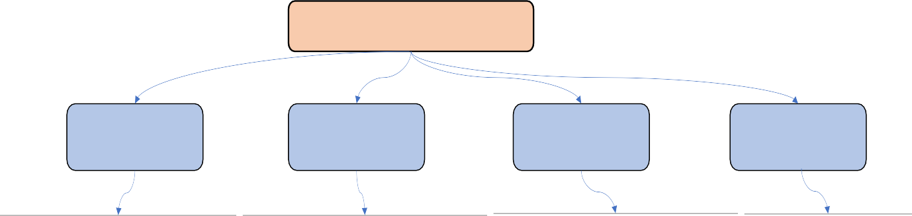

Laundry Management System

Business Analyst

Developer

UI/UX Designer

SQA Engineer

Planning

Software Development

Wireframing

Requirements Analysis

|  |  |  |  |
| --- | --- | --- | --- |
| Cost and Schedule Management | Database Design and Implementation | Request Specifications | Test Planning |
| Task Management | Integration Third-Party Components | Work Package Definition | Test Case Design |
| Project Communication | Frontend Development | Software Prototyping | Test Data Preparation |
| Risk Management | Backend Development | Unit Detailed Design | Execution of Test Cases |
| Quality Management | User Authentication | Ui Design | Performance Testing |
| Technical Planning | Security Implementation | Collaboration With Development team | Security Testing |
| Technical Supervision | Bug Fixing | Usability Testing |
| Business Requirements Supervision | Performance Optimization Defects Tracking | | |
| Requirements Definition | Deployment and Maintenance |  | Documentation |

# 11.0 Activity Diagram:

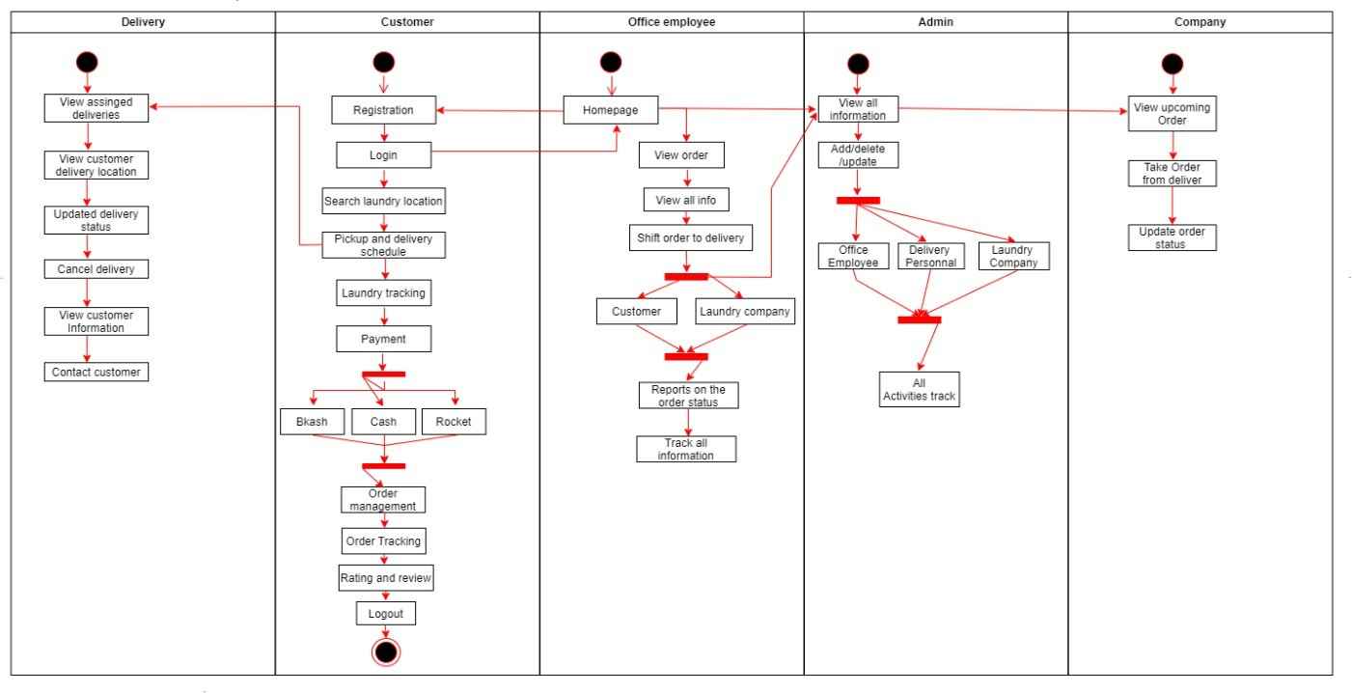

### Figure 2: Activity Diagram.

The diagram is about the activity diagram. In this activity diagram, we can see the activity of the laundry Management System where customers have to log in to this website and then check login details and permission. After that customer can go to check the status of the clothes, manage the location, and manage to make payment. Then admin manages the plot, checks records & books, and set work.

# 12.0 Risk Analysis:

In a laundry management system, conducting a comprehensive risk analysis helps identify potential threats, vulnerabilities, and uncertainties that could affect the system's success. Here's an outline of how to approach risk analysis for such a system:

## Identify Risks:

* + Technical Risks: Hardware or software failures, integration issues, data loss.
  + Operational Risks: Process inefficiencies, lack of training, inadequate maintenance.
  + Security Risks: Data breaches, unauthorized access, cyber-attacks.
  + Market Risks: Changes in customer demand, competition, regulatory changes.
  + Financial Risks: Budget overruns, unforeseen costs, fluctuations in expenses.

## Risk Assessment:

* + Impact Analysis: Evaluate the potential impact of each risk on the system, considering factors like downtime, financial loss, reputation damage.
  + Likelihood Assessment: Determine the probability or likelihood of each risk occurrence.

## Risk Prioritization:

* + Categorize risks based on severity (high, medium, low) by considering their impact and likelihood.
  + Focus on high-priority risks that could significantly impact the system.

## Risk Mitigation:

* + Risk Avoidance: Eliminate the risk by avoiding the action causing it (e.g., choosing a more reliable technology).
  + Risk Transfer: Shift the risk to another party (e.g., outsourcing certain operations).
  + Risk Reduction: Implement measures to reduce the probability or impact of the risk (e.g., implementing security measures, redundancy in systems).
  + Risk Acceptance: Accept the risk if its impact is minimal or the cost of mitigation outweighs the risk itself.

## Contingency Planning:

* + Develop contingency plans for high-priority risks, outlining steps to be taken if they occur.
  + Allocate resources or create fallback strategies to mitigate the impact of these risks.

## Monitoring and Review:

* + Regularly monitor the identified risks and the effectiveness of mitigation strategies.
  + Update risk assessments as the project progresses or as new risks emerge.

## Documentation:

* + Maintain a comprehensive record of identified risks, their potential impact, mitigation strategies, and their current status.
  + Use this documentation for reference and to inform decision-making throughout the project lifecycle.

By systematically identifying, analyzing, and mitigating risks, a laundry management system can be better prepared to handle potential challenges, ensuring smoother operations and reducing the impact of unforeseen events on the system's performance and success.

# Budget for the project

For develop the software:

* + Developer team of 5 engineers.
  + Software Quality assurance team of 2 engineers.
  + One Business Analyst
  + Two Ui/UX Designer
  + Total budget: **5,500,000 BDT**

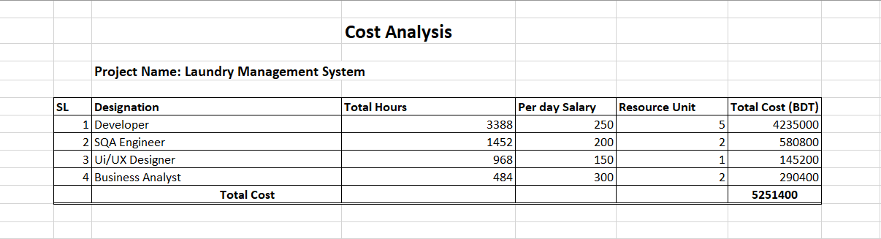

**Now, All together**

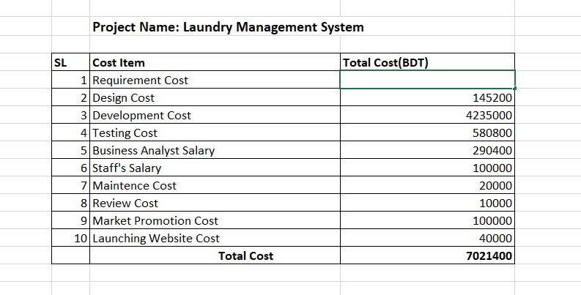

* 1. **Profit:**

Those who will use their grave space in the cemetery have to buy a maintenance cost. We set our monthly maintenance rate at 250 BDT. We are assuming at least 2550 people will use our app.

So, 2550 X 250 = 637,500 BDT

So, in 22 months it will be 637500 *22 = 14025000 BDT

Our Total Development cost = 7021400 BDT So, earnings on this website = 14025000 BDT

So, we are getting (14025000-7021400) = 7003600 BDT profit. After one-year subscription fee will be reduced.

# 14.0 Conclusion:

The Laundry Management System (LMS) represents a transformative approach to modernizing the traditional laundry industry. By leveraging digital technologies, it enhances operational efficiency, user experience, and overall service quality. The introduction of an LMS addresses multiple challenges inherent in manual processes, from human errors to inefficiencies in order management and tracking. From an operational perspective, the system facilitates streamlined workflows, real-time monitoring, and data-driven insights. This not only ensures consistency and reliability in service but also empowers businesses to make informed decisions, be it in resource allocation, pricing strategies, or expansion plans.

Economically, the LMS can be a cornerstone for cost-saving and revenue generation. By minimizing manual interventions and errors, businesses can cut down operational costs. Simultaneously, features like online booking, promotions, and loyalty programs attract a wider user base, driving revenue growth. For users, the benefits are manifold. The convenience of online scheduling, transparent pricing, real-time tracking, and digital payments significantly enhances their experience. Feedback mechanisms further give them a voice, ensuring service providers remain responsive to their needs. Environmentally, an LMS paves the way for sustainability. With insights into water and energy consumption, businesses are better positioned to adopt eco-friendly practices. Moreover, optimized routing for pickups and deliveries reduces fuel consumption, contributing to a lower carbon footprint. However, the digital transition also underscores the importance of data security and user privacy. It's imperative that LMS platforms uphold the highest standards in these areas to maintain user trust.

In conclusion, the Laundry Management System is not merely a digital tool but a comprehensive solution reshaping the laundry service industry. It bridges the gap between traditional practices and contemporary user expectations, fostering growth, sustainability, and enhanced service quality. As technology continues to evolve, the LMS's capabilities and benefits are only set to expand, solidifying its role as an indispensable asset in the laundry domain.